

D. Y. Patil Agricultural and Technical University
Talsande

PROJECT REPORT on
Strategic Product Placement Analysis: Unveiling Sales Impact with Tableau Visualization

Department
Master Of Computer Applications
(MCA-Sandwich Sem-II)

Submitted By

1. Kartik Kamble
2. Hitakshi Ahuja
3. Rutuja Patil
4. Pratik Patil

2026-2027

Sr. No. | Title | Page No.
1 | INTRODUCTION  - Project Overview  - Purpose | 3
2 | IDEATION PHASE  2.1 Problem Statement  2.2 Empathy Map Canvas  2.3 Brainstorming | 4
3 | REQUIREMENT ANALYSIS  3.1 Customer Journey map  3.2 Solution Requirement  3.3 Data Flow Diagram  3.4 Technology Stack | 5
4 | PROJECT DESIGN  4.1 Problem Solution Fit  4.2 Proposed Solution  4.3 Solution Architecture | 6
5 | PROJECT PLANNING & SCHEDULING  5.1 Project Planning | 7
6 | FUNCTIONAL AND PERFORMANCE TESTING  6.1 Performance Testing | 8-9
7 | RESULTS  7.1 Output Screenshots | 10
8 | ADVANTAGES & DISADVANTAGES | 11-12
9 | CONCLUSION | 13
10 | FUTURE SCOPE | 14-16
11 | APPENDIX  11.1 Source Code (if any)  11.2 Dataset Link  11.3 GitHub & Project Demo Link | 17

INTRODUCTION

1.1 Project Overview
In today’s competitive business environment, companies rely on data analysis to improve their sales and marketing strategies. Product placement plays an important role in influencing customer purchasing decisions. Strategic product placement involves positioning products in such a way that they attract customers and increase sales.
This project focuses on analysing sales data to understand how product placement impacts sales performance. By using data visualization tools like Tableau, raw sales data can be transformed into interactive dashboards and meaningful insights. These dashboards help businesses easily identify trends, patterns, and customer preferences.
Through this project, sales data is analysed based on product category, region, and time. The visualization helps businesses understand which products perform well and how product placement strategies can improve overall revenue.

1.2 Purpose
The purpose of this project is to analyse sales data and determine how product placement strategies affect sales performance. The project uses Tableau to create interactive dashboards that help visualize relationships between products, locations, and customer buying behaviour.
The main goal is to provide insights that help businesses make better decisions regarding product placement, marketing strategies, and sales planning. By understanding which products generate higher sales and where they perform best, organizations can optimize their product positioning and improve overall business performance.

IDEATION PHASE

2.1 Problem Statement
Many businesses collect large amounts of sales data but struggle to extract useful insights from it. Without proper analysis, companies cannot clearly understand which products are performing well or how product placement influences sales.
As a result, businesses may make decisions based on assumptions rather than data-driven insights. This may lead to inefficient product positioning, reduced sales performance, and missed business opportunities.
This project aims to solve this problem by analysing sales data and presenting insights using Tableau dashboards. These visualizations help identify sales patterns and evaluate the effectiveness of product placement strategies.

2.2 Empathy Map Canvas
The empathy map helps understand the needs and expectations of stakeholders such as business managers, marketing teams, and analysts.
Think:
Managers want to improve product visibility and increase sales.
Feel:
They feel uncertain about which product placement strategies work best.
Say:
They often say that better insights from data can help them make better business decisions.
Do:
They analyse sales reports, monitor product performance, and adjust marketing strategies.
Pain:
Large datasets are difficult to analyse manually, and valuable insights may be missed.
Gain:
Interactive dashboards and visual analytics help them quickly understand sales patterns and optimize product placement strategies.

2.3 Brainstorming
During brainstorming, several ideas were generated to improve the understanding of product placement and sales performance.
Some of the main ideas include analysing sales trends by product category, studying regional sales performance, identifying best-selling products, and visualizing monthly or yearly sales growth. Another idea is to analyse profit margins and compare them with sales performance to understand which products are most profitable.
Using Tableau dashboards makes it easier to present these insights visually so that decision-makers can quickly interpret the data and take appropriate action.

REQUIREMENT ANALYSIS

3.1 Customer Journey Map
The customer journey map represents the steps involved in analysing sales data and generating insights.
- The process begins with collecting sales data from available datasets.
- The collected data is cleaned and prepared for analysis by removing errors and missing values.
- The processed dataset is then imported into Tableau.
- Various visualizations such as bar charts, line charts, and dashboards are created.
- Users interact with the dashboard to explore sales trends and patterns.
- Based on these insights, businesses can improve product placement strategies.

3.2 Solution Requirement
Functional Requirements
- Import and manage sales datasets.
- Create interactive dashboards using Tableau.
- Visualize sales performance across product categories.
- Analyse regional and time-based sales trends.
- Provide filters and interactive features for deeper analysis.

Non-Functional Requirements
- The system should be easy to use and understand.
- Dashboards should display data quickly and accurately.
- Visualizations should be clear and informative.
- The system should support large datasets efficiently.

Data Flow Diagram

Level 0 DFD
User → Dataset → Tableau Visualization → Sales Insights → Decision Making

Level 1 DFD

Dataset → Data Cleaning → Data Processing → Tableau Dashboard → Business Analysis
Technology Stack

Technology | Description
Tableau 2026.1 | Used for data visualization and dashboard creation
Excel | Used as the dataset source
Python (Flask) | Used for creating web app
GitHub | Used for storing project files and version control
Web Browser | Used to access dashboards and project repository
PROJECT DESIGN

4.1 Problem Solution Fit
The project addresses the problem of understanding product placement effectiveness by converting raw sales data into visual insights. Tableau dashboards allow users to easily interpret sales trends and identify which products generate the most revenue. This helps businesses make informed decisions about product placement strategies.

4.2 Proposed Solution
The proposed solution is to create an interactive data visualization dashboard using Tableau. The dashboard will display various sales metrics such as product category performance, regional sales distribution, profit analysis, and sales trends over time.
These visualizations help users analyse patterns and identify opportunities to improve product placement strategies.

4.3 Solution Architecture

Data Source (Sales Dataset)
↓
Data Cleaning and Preparation
↓
Tableau Visualization and Dashboard Creation
↓
Sales Analysis and Insights
↓
Business Decision Making

PROJECT PLANNING & SCHEDULING

5.1 Project Planning
The project was divided into several phases to ensure proper implementation.
- Data collection from online datasets.
- Data cleaning and preprocessing.
- Importing dataset into Tableau.
- Creating charts and dashboards.
- Testing and validating visualizations.
- Publishing the project on GitHub and Tableau Public.

FUNCTIONAL AND PERFORMANCE TESTING

6.1 Performance Testing

Test Case | Expected Result
Load dataset | Dataset loads successfully
Create visualization | Charts display correct values
Apply filters | Dashboard updates dynamically
Analyse trends | Sales patterns are clearly visible

RESULTS

7.1 Output Screenshots
The project generates interactive dashboards that display various insights such as sales trends, product category performance, and regional sales distribution. Screenshots of the Tableau dashboard, charts, and analysis results are included in this section to demonstrate the output of the project.

- Data Collection and Extraction:

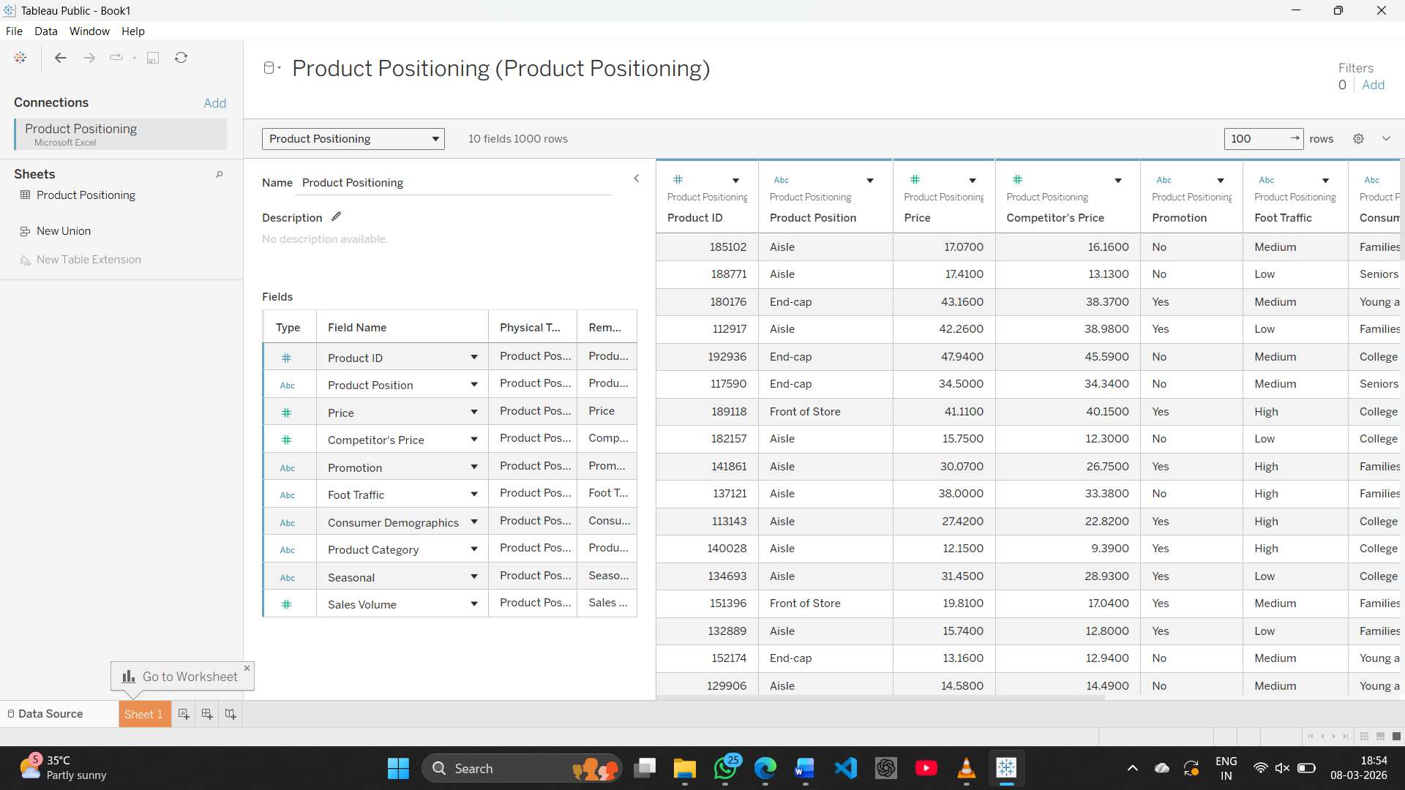

- Data Preparation and Data Visualization

Sheet 1 - Sales Trends
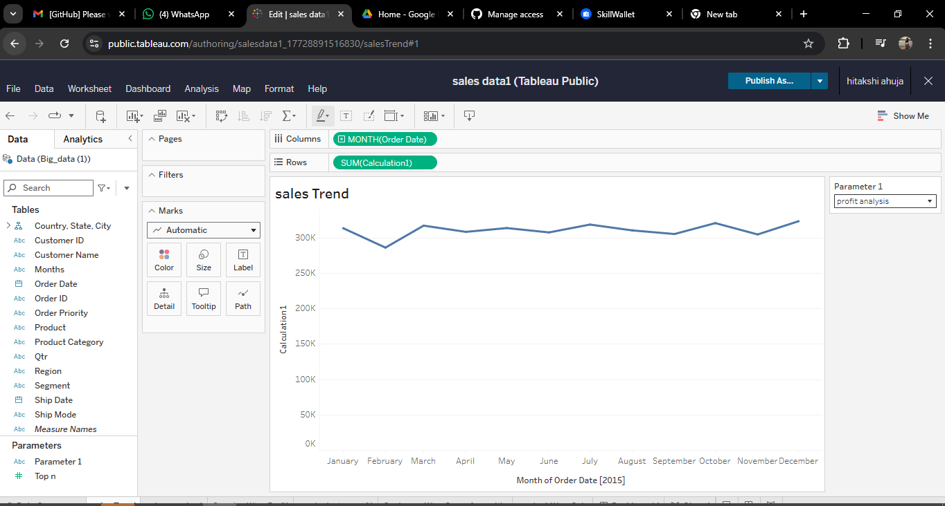
Sheet 2 - Cateorgry Chart
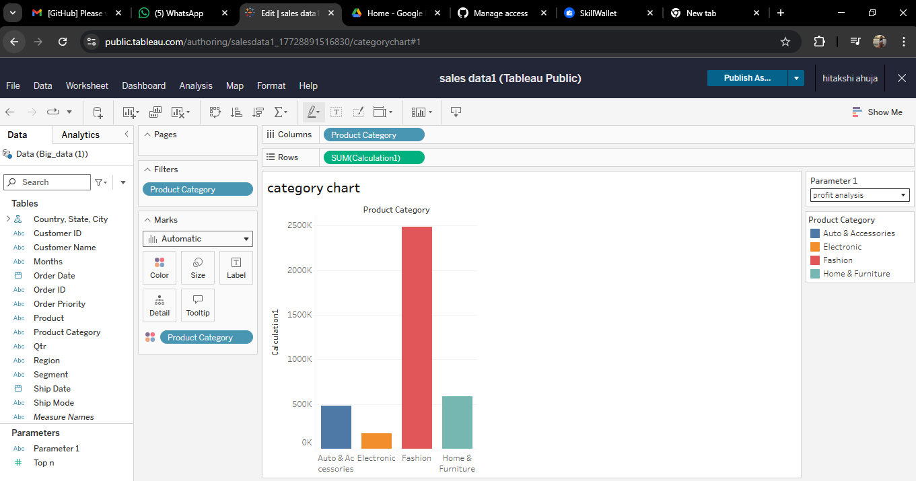

Sheet 3 - Product wise profit
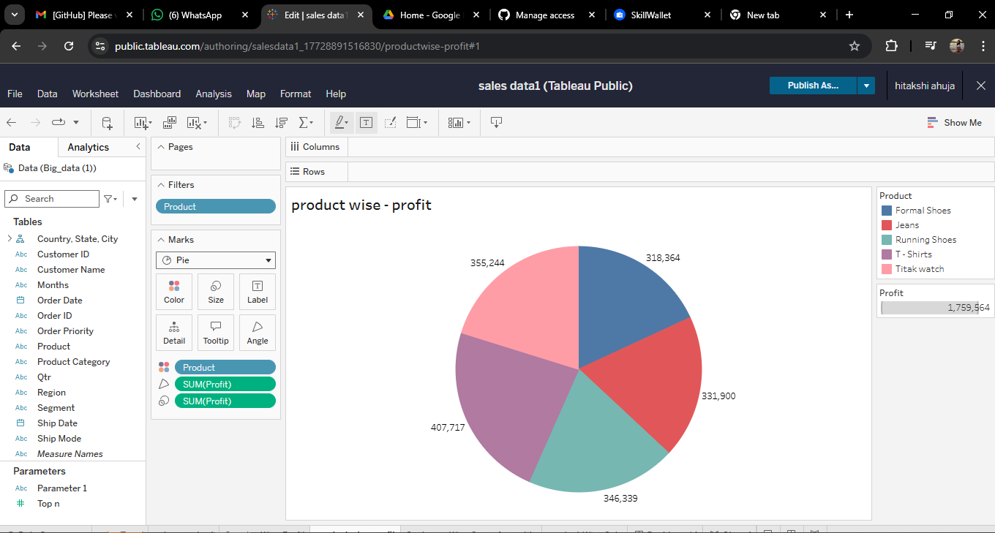

Sheet 4 - Country-wise profit

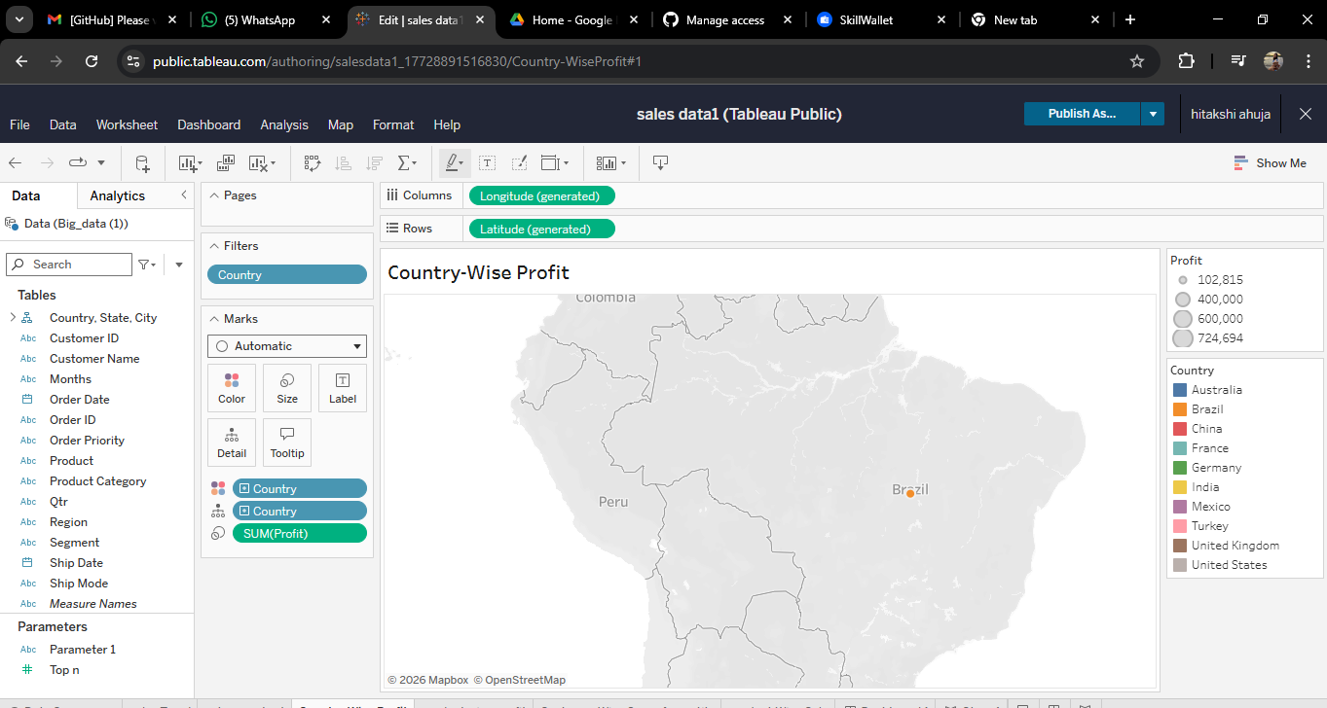

Sheet 5 - Customer Wise Sum of Quantity

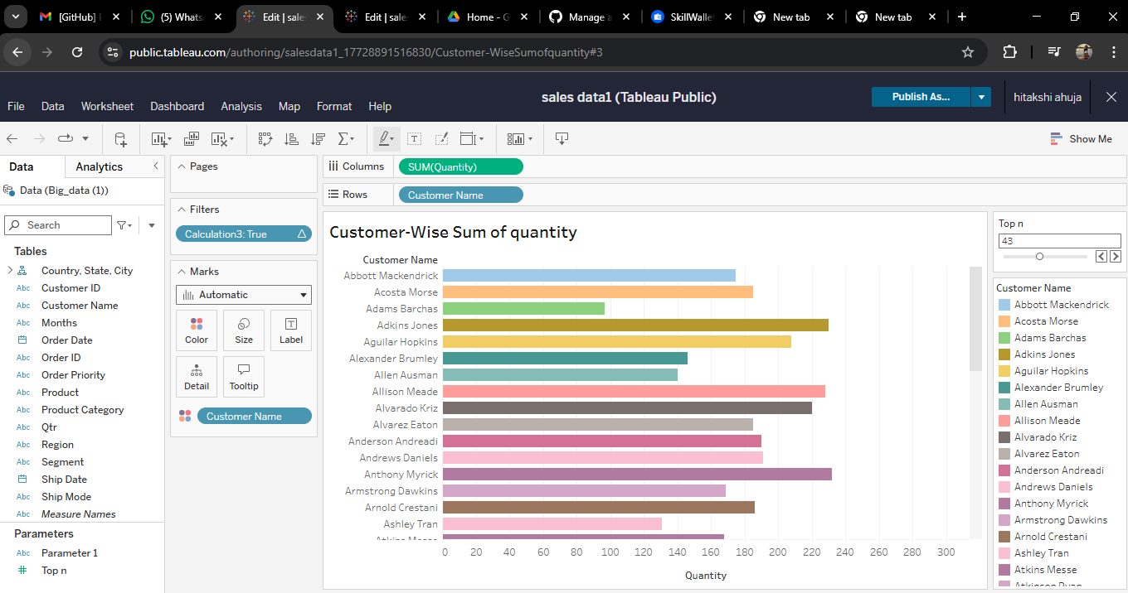

Sheet 6 - Product Wise Sales
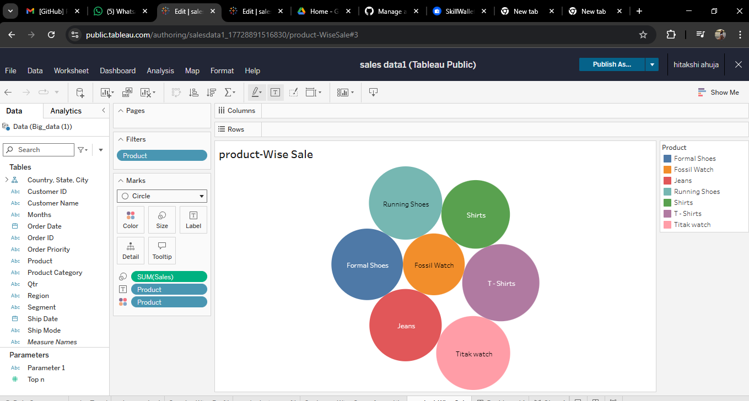

- Design of Dashboard
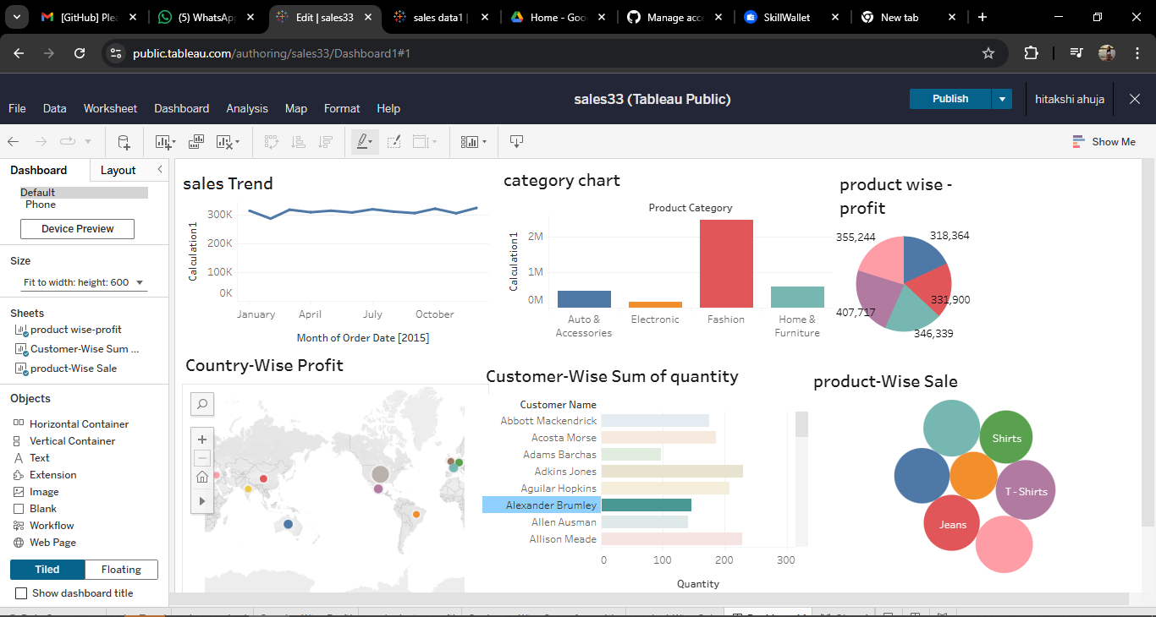

- Scenes of Story
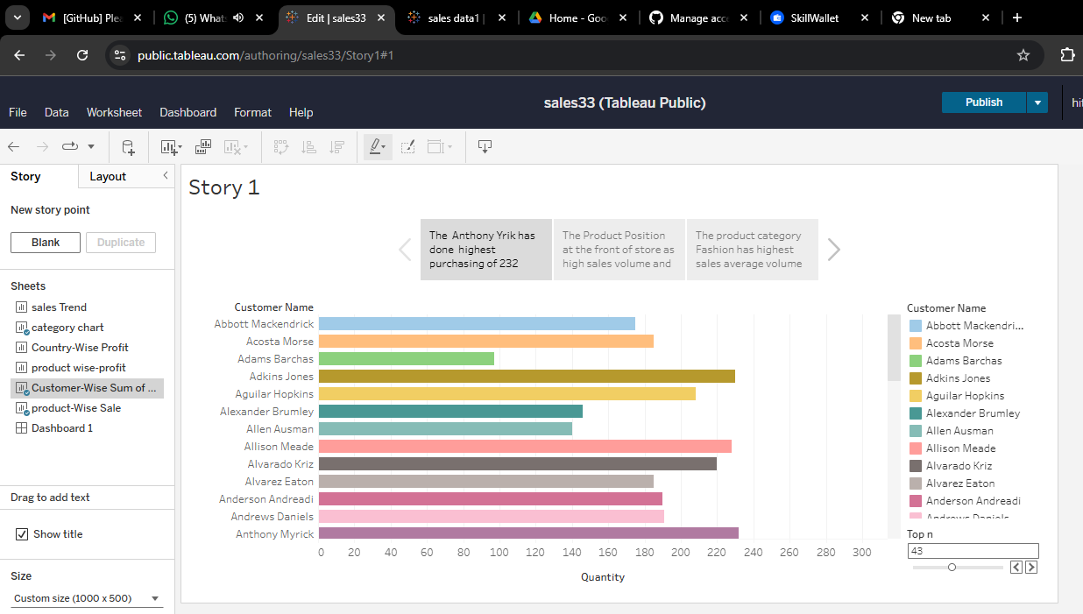

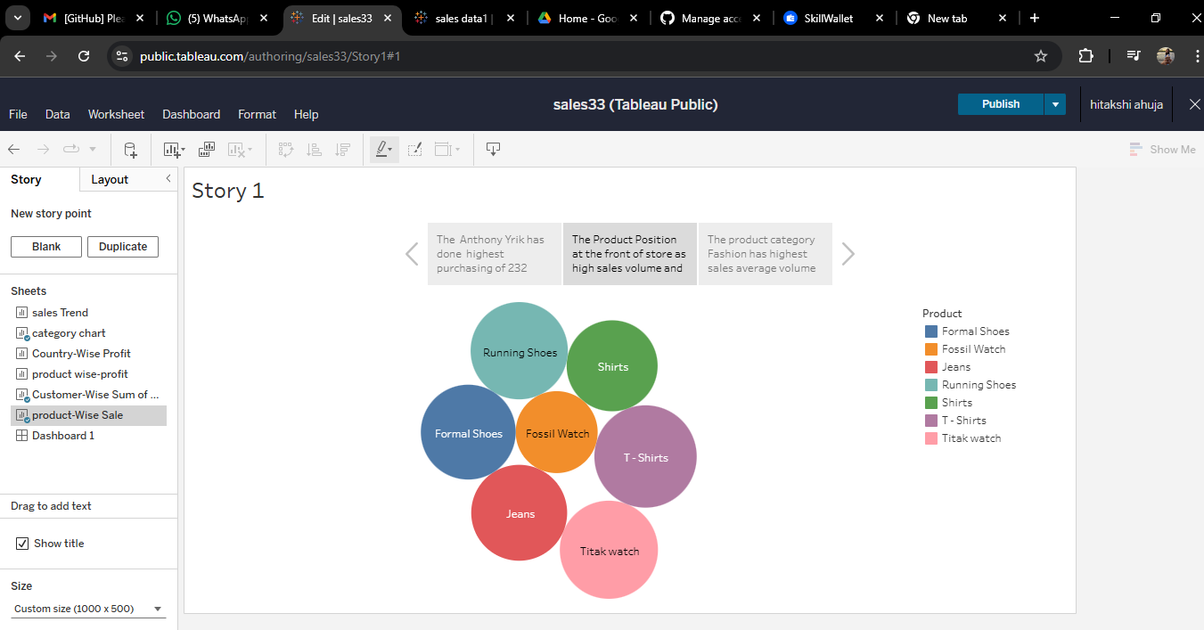

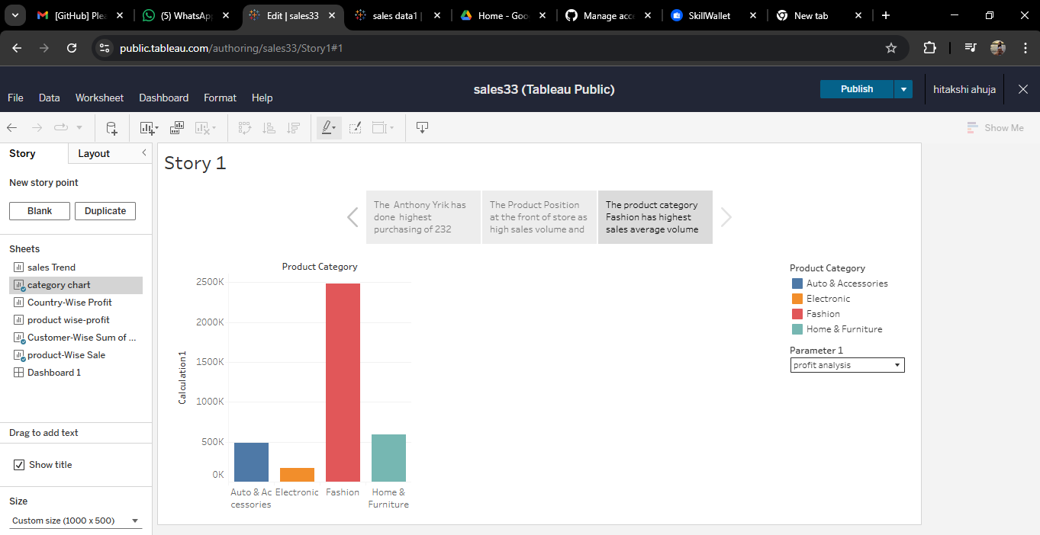

- Publishing
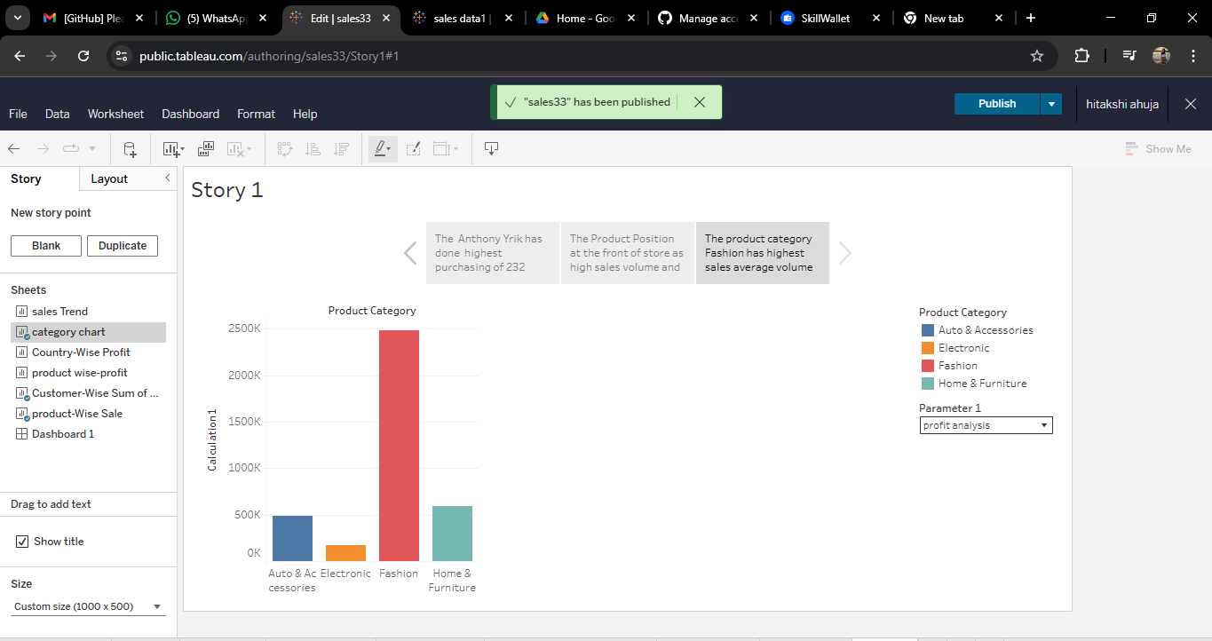

- Dashboard and Story Embed with UI with Flask


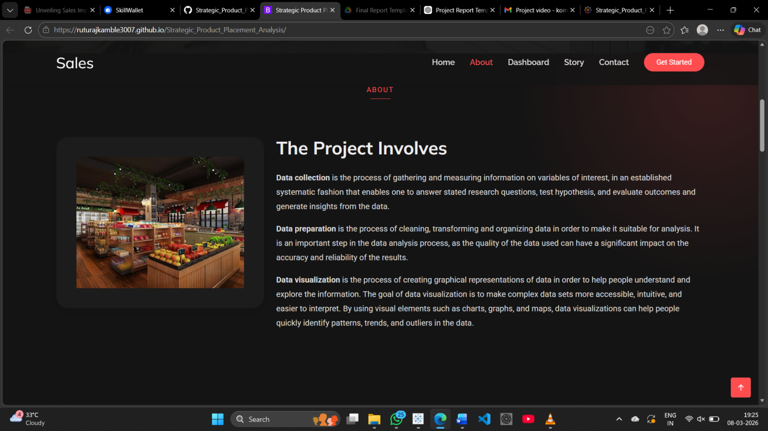

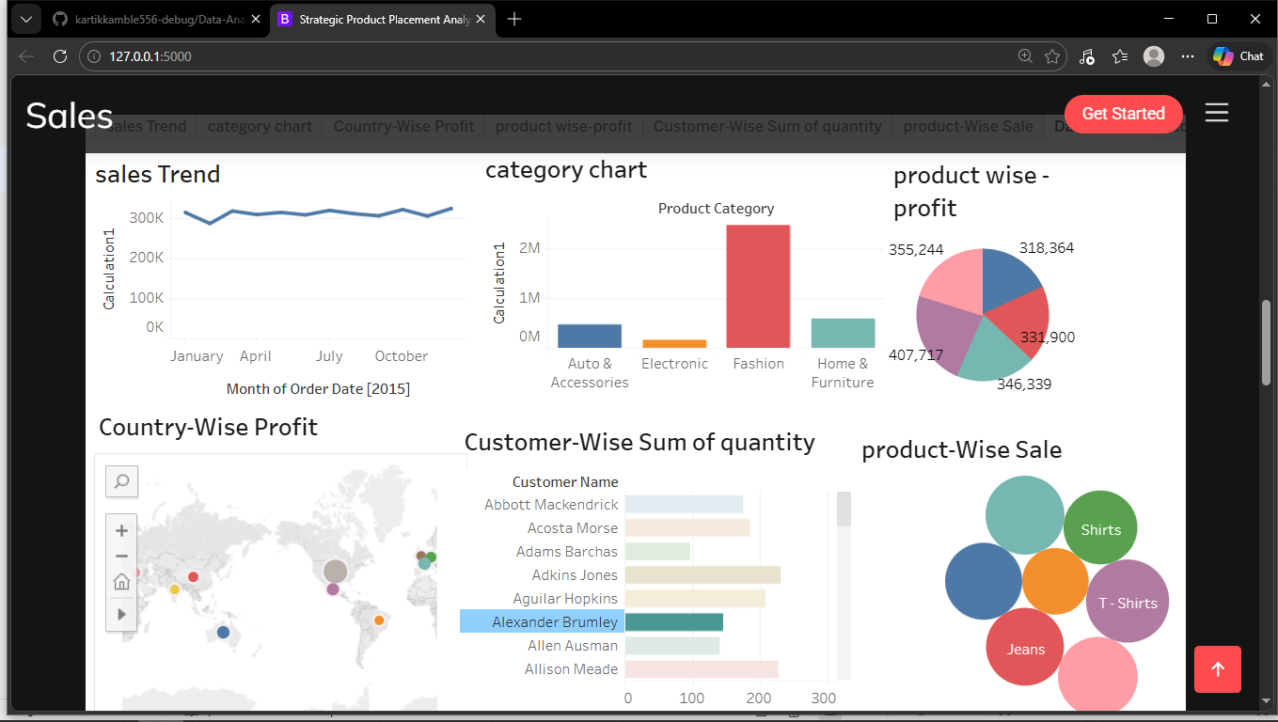

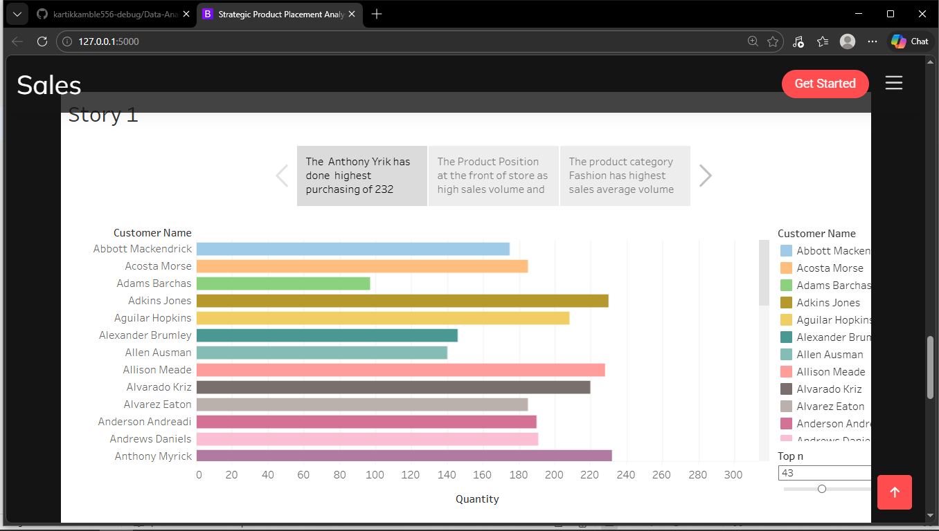


ADVANTAGES & DISADVANTAGES

Advantages
- Provides clear visualization of complex sales data.
- Helps businesses identify profitable products.
- Supports better strategic decision-making.
- Interactive dashboards make analysis easier.

Disadvantages
- Insights depend heavily on the quality of data.
- Limited analysis if dataset is small or incomplete.
- Requires knowledge of Tableau for advanced analysis.

CONCLUSION

The Strategic Product Placement Analysis project demonstrates the importance of data visualization in understanding sales performance. By using Tableau dashboards, businesses can easily identify patterns in sales data and evaluate the effectiveness of product placement strategies.
The project shows how visual analytics can transform raw data into meaningful insights that support data-driven decision-making and improve overall business performance.

FUTURE SCOPE

Future improvements can enhance the capabilities of this project. The system can be integrated with real-time sales databases to provide up-to-date insights.
Machine learning techniques can also be applied to predict future sales trends and recommend optimal product placement strategies.
Additionally, the project can be extended by developing web-based dashboards or integrating it with business intelligence platforms for more advanced analytics.

APPENDIX

- Kaggle Sales Dataset:
https://www.kaggle.com/datasets/amitvkulkarni/impact-of-product-positioning-on-sales

- Tableau Public Dashboard:
https://public.tableau.com/views/sales33/Dashboard1?:language=en-US&:sid=&:redirect=auth&:display_count=n&:origin=viz_share_link
- GitHub Repository:
https://github.com/kartikkamble556-debug/Data-Analysis-dashboard/settings/access?guidance_task=
- Demo Video:
https://drive.google.com/file/d/1-Q-SdpSdcAbXK7OEAqoWFBbHuDHhBSPu/view?usp=drive_link

